Part 1

1. Kaggle name: TonyHuang42
2. Best accuracy: 62.9%

|  |  |  |  |  |
| --- | --- | --- | --- | --- |
| layer No. | Layer Type | Kernel Size  (for conv layers) | Input | Output Dimension | Input | Output Channels (for conv layers) |
| 1 | conv2d | 3 | 32 | 32 | 3 | 64 |
| 2 | BatchNorm2d | - | 32 | 32 | - |
| 3 | ReLU | - | 32 | 32 | - |
| 4 | conv2d | 3 | 32 | 32 | 64 | 64 |
| 5 | BatchNorm2d | - | 32 | 32 | - |
| 6 | ReLU | - | 32 | 32 | - |
| 7 | MaxPool2d | - | 32 | 16 | - |
| 8 | conv2d | 3 | 16 | 16 | 64 | 128 |
| 9 | BatchNorm2d | - | 16 | 16 | - |
| 10 | ReLU | - | 16 | 16 | - |
| 11 | conv2d | 3 | 16 | 16 | 128 | 128 |
| 12 | BatchNorm2d | - | 16 | 16 | - |
| 13 | ReLU | - | 16 | 16 | - |
| 14 | MaxPool2d | - | 16 | 8 | - |
| 15 | conv2d | 3 | 8 | 8 | 128 | 256 |
| 16 | BatchNorm2d | - | 8 | 8 | - |
| 17 | ReLU | - | 8 | 8 | - |
| 18 | conv2d | 3 | 8 | 8 | 256 | 256 |
| 19 | BatchNorm2d | - | 8 | 8 | - |
| 20 | ReLU | - | 8 | 8 | - |
| 21 | conv2d | 3 | 8 | 8 | 256 | 256 |
| 22 | BatchNorm2d | - | 8 | 8 | - |
| 23 | ReLU | - | 8 | 8 | - |
| 24 | MaxPool2d | - | 8 | 4 | - |
| 25 | conv2d | 3 | 4 | 4 | 256 | 512 |
| 26 | BatchNorm2d | - | 4 | 4 | - |
| 27 | ReLU | - | 4 | 4 | - |
| 28 | conv2d | 3 | 4 | 4 | 512 | 512 |
| 29 | BatchNorm2d | - | 4 | 4 | - |
| 30 | ReLU | - | 4 | 4 | - |
| 31 | conv2d | 3 | 4 | 4 | 512 | 512 |
| 32 | BatchNorm2d | - | 4 | 4 | - |
| 33 | ReLU | - | 4 | 4 | - |
| 34 | MaxPool2d | - | 4 | 2 | - |
| 35 | Linear | - | 2048 | 256 | - |
| 36 | BatchNorm1d | - | 256 | 256 | - |
| 37 | ReLU | - | 256 | 256 | - |
| 38 | Linear | - | 256 | 256 | - |
| 39 | BatchNorm1d | - | 256 | 256 | - |
| 40 | ReLU | - | 256 | 256 | - |
| 41 | Linear | - | 256 | 100 | - |

ablation study: for the BaseNet, it only has 23% accuracy, after I create a much deeper network with 41 layers, the accuracy increases to 63%.

Part 2:

1. fixed feature extractor train accuracy: 62.7%

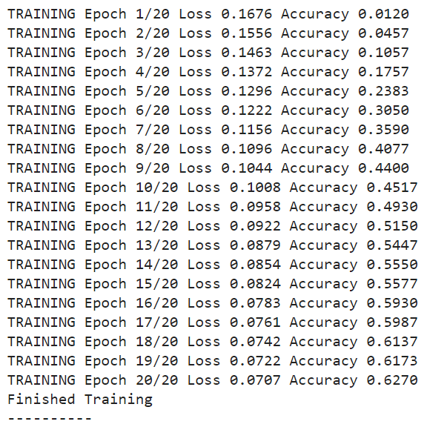

fixed feature extractor test accuracy: 40.92%



fine-tuning the whole network train accuracy: 86.1%

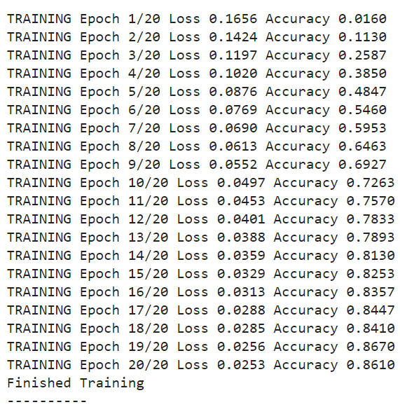

fine-tuning the whole network test accuracy: 55.82%



1. batch_size: 32

learning_rate: 0.002

resnet_last_only: False

num_epochs: 20